A Report on

DRIVER DROWSY DETECTION
Submitted in partial fulfillment of the
Academic Requirement for the Award
of Degree of
BACHELOR OF TECHNOLOGY
in
COMPUTER SCIENCE AND ENGINEERING
Submitted By

SAICHARAN 24R05A0514
MANVITH 24R05A0531
AJAY 24R05A0517
SRIVASTHAV 24R05A0506

Under the esteemed guidance of
MS. SHAHZADI ASRE (Assistant professor)
(Associate Professor, Dept. of CSE)


CMR INSTITUTE OF TECHNOLOGY

(UGC AUTONOMUS)
Approved by AICTE, Permanent Affiliation to JNTUH, Accredited by NBA and NAAC
Kandlakoya(V), Medchal Dist – 501401
www.cmrithyderabad.edu.in
2023 – 24

CMR INSTITUTE OF TECHNOLOGY
(UGC AUTONOMOUS)
(Approved by AICTE, Affiliated to JNTU, Kukatpally, Hyderabad) Kandlakoya, Medchal Road, Hyderabad.

CERTIFICATE
This is to certify that a Real Time Societal Research Project entitled with: DRIVER DROWSY DETECTION is being

Submitted By

SAICHARAN 24R05A0514
MANVITH 24R05A0531
AJAY 24R05A0517
SRIVASTHAV 24R05A0506

In partial fulfillment of the requirement for award of the Real Time Societal Research Project Laboratory of II B. Tech II Semester in CSE to the CMRIT, Hyderabad is a record of a bonafide work carried out under our guidance and supervision.

Signature of Faculty Signature of H MS. MS.SHAHZADI ASRE
Mr. A. Prakash
(Associate Professor) (Head of Department)

Signature of External Examiner

Advance Drivers’ Drowsiness Detection

ABSTRACT:

Driver fatigue is a significant factor in a large number of vehicle accidents. The development of technologies for detecting drowsiness at the wheel is a major challenge in the field of accident avoidance systems. Because of the hazard that drowsiness presents on the road, methods need to be developed for counteracting its affects. The main aim of this is to develop a drowsiness detection system by monitoring the eyes; it is believed that the symptoms of driver fatigue can be detected early enough to avoid a car accident. Detection of fatigue involves the observation of eye movements and blink patterns. The analysis of face images is a popular research area with applications such as face recognition. This project is focused on the localization of the eyes, which involves looking at the entire image of the eye, and determining the position of the eyes, by a self-developed image-processing algorithm using python running on Laptop.

EXISTING SOLUTION:

To overcome the limitations of current drowsiness detection methods, driver fatigue is a significant factor in a large number of vehicle accidents especially on Police Accident Reports and in accident data files. A Drowsy Driver Detection System uses a specially designed matlab based algorithm that points directly towards the driver’s eyes in order to detect fatigue. In such a case when fatigue is detected, a warning signal is issued to alert the driver which is costly and not efficient. It takes long time to process and not user friendly. This closed approach also prevents further research and development of the system at affordable price from many free sources like python which is one of the latest boom in technology.

PROPOSED SOLUTION:

This proposed research aims to develop a real-time, easy implementable, nonintrusive, and accurate drowsiness detection system for the road safety where the focus will be placed on designing a system that will accurately monitor the open or closed state of the driver’s eyes in real-time. The eye status in our project is based on retinal reflection and thus is more accurate. And also we are detecting status of mouth and yawning we can help us further to detect drowsiness. By monitoring the eyes and mouth , it is believed that the symptoms of driver fatigue can be detected early enough to avoid a car accident with user friendly technology i.e. python and opencv which compiles and process the data very fast compared to other technologies.

INTRODUCTION:

The attention level of driver degrade because of less sleep, long continuous driving or any other medical condition like brain disorders etc. Several surveys on road accidents says that around 30 percent of accidents are caused by fatigue of the driver. When driver drives for more than normal period for human then excessive fatigue is caused and also results in tiredness which drives the driver to sleepy condition or loss of consciousness. Drowsiness is a complex phenomenon which states that there is a decrease in alerts and conscious levels of the driver. Though there is no direct measure to detect the drowsiness but several indirect methods can be used for this purpose. In initial sections different types of methods for measuring the drowsiness of the driver are mentioned which includes Vehicle based measures, Physiological measures, Behavioural measures. Using those methods an intelligence system can be developed which would alert the driver in case drowsy condition and prevent accidents. Advantages and dis advantages corresponding to each and every system is explained. Depending on advantages and disadvantages the most suitable method is chosen and proposed. Then the approach for entire system development is explained using a flow chart which includes capturing the image in real time continuously, then dividing it into frames. Then each frames are analyzed to find face first. If a face is detected then then next task is to locate the eyes. After the positive result of detecting eye the amount of closure of eye is determined and compared with the reference values for the drowsy state eye. If drowsy condition is found out then driver is alarmed else repeatedly the loop of finding face and detecting drowsy condition is carried out.

Hardware Requirement:
Processor: i4 or above
Storage: 120 GB or Above
RAM: 8GB or Above
Good Quality Webcam

Software Requirements:
OS: Windows 10
Language: Python 3.9 or Above
IDE: VS Code
Block Diagram:

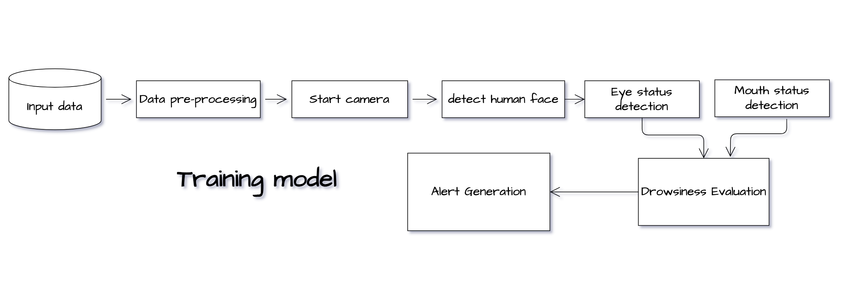

Flow chart:
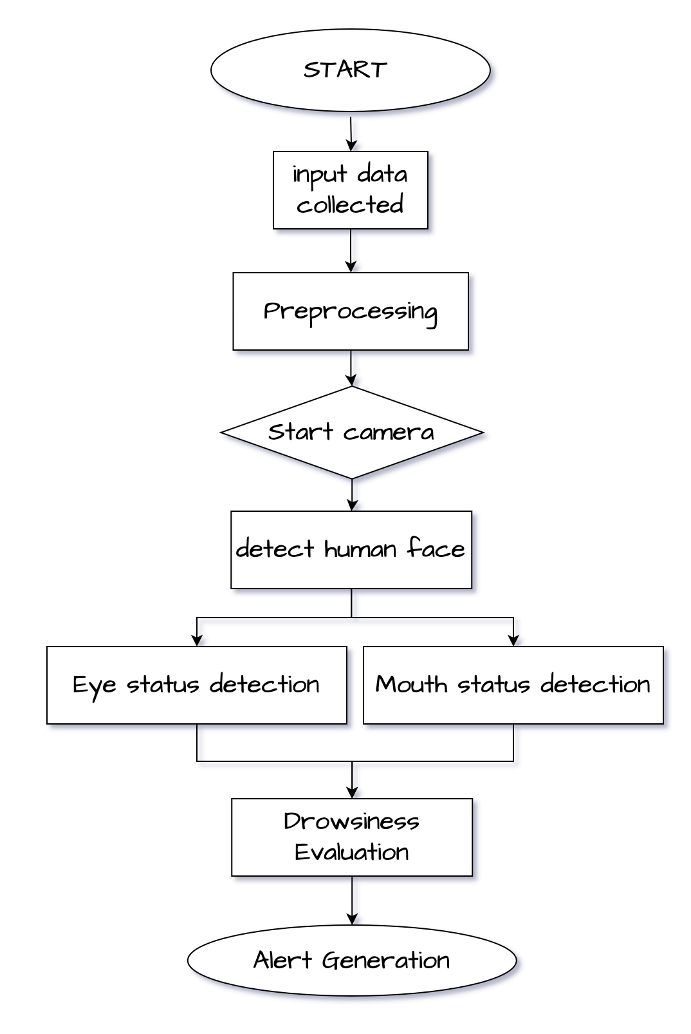

Use-case Diagram:

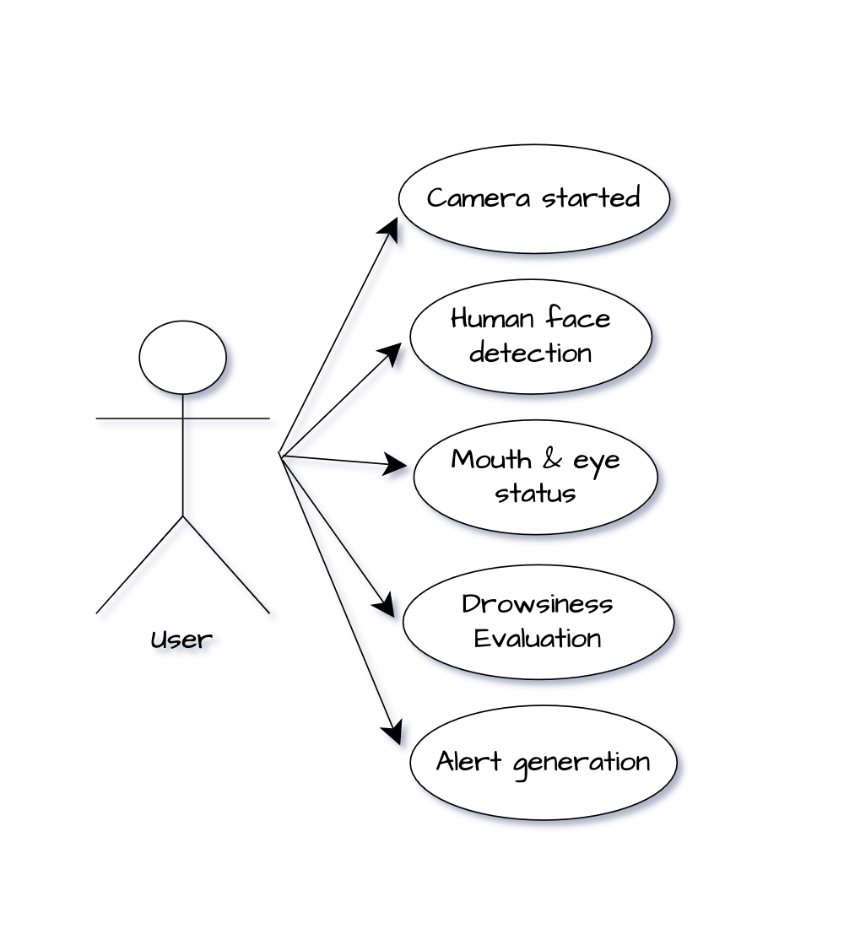

Software Design Method

Software design is the process of conceptualizing the software requirements of a software implementation. Software design takes user requirements as an issue and seeks to find the best solution. Once the software is conceptualized, a plan is created to find the best design to implement the desired solution.

There are several variations in software design. Let's take a quick look at them:

Structured Design

Structured design conceptualizes the problem into several well-organized solution elements. It is something about the essentially solutions of design. The advantage of structured design is that you can better understand what is resolved how the problem. The structured design, the designer makes it easy to further concentrate on the problem.

Structured design is based mainly on the "divide and conquer" strategy. In this strategy, is divided into a plurality of small problem is a problem, until the whole issue is resolved, small problems will be resolved one by one.

Small problems are resolved by the components of the solution. The structured design emphasizes that these modules are properly organized to achieve an accurate solution.

These modules are arranged hierarchically. They communicate with each other. A well-structured design always adheres to some rules for communication between multiple modules:
Cohesion - grouping of all functionally related elements.
Coupling communications between different modules.

A well-structured design with high cohesion and low coupling.

Function-oriented design

In a function-oriented design, a system consists of many small subsystems called functions. These features allow you to perform important tasks on your system. The system is displayed as a top view of all features.
Function-oriented design inherits some characteristics of structured design using divide-and-conquer method.

This design mechanism provides a means of abstraction by dividing the entire system into smaller functions and hiding information and its operations. These functional modules can exchange information with each other by passing information or using globally available information.

Another characteristic of a function is that when a program calls a function, that function changes the state of the program. This may not be acceptable in other modules. Function-oriented design works well when the state of the system is not important and the program / function works on the input rather than the state.

Design process

- The entire system is displayed as a data flow in the system using a data flow diagram.
- DFD shows how a function changes the data and state of the entire system.
- The entire system is logically divided into smaller units called functions based on how it behaves within the system.
- The functions are then implemented.

Object-oriented design

Object-oriented design avoids entities and their properties rather than the features contained in the software system. This design strategy focuses on the entity and its properties. The overall concept of a software solution revolves around the units involved.

Let's review the important concepts of object-oriented design.

- Objects - All entities involved in solution design are called objects. For example, people, banks, businesses, and customers are treated as objects. Each entity has several attributes associated with it, and there are several methods to execute on those attributes.
- Class - A class is a generalized description of an object. The object is an instance of the class. The class defines all the attributes that an object can have and the methods that define the functionality of the object.

- In solution design, attributes are stored as variables and functions are defined by methods or procedures.

- Encapsulation - OOD bundles attributes (data variables) and methods (operations on data), which is called encapsulation. Encapsulation not only bundles important information about an object, but also limits access to data and methods from the outside. This is known as hiding information.

- Inheritance - OOD allows you to stack similar classes hierarchically. Subclasses or subclasses can import, implement, and reuse valid variables and methods from direct superclasses. This property of OOD is called inheritance. This makes it easy to define a particular class and create a generalized class from a particular class.

- Polymorphism - The polymorphism OOD language provides a mechanism that allows methods that perform similar tasks but have different arguments to have the same name. This is called polymorphism and allows you to perform different types of tasks with a single interface. The appropriate part of the code is executed, depending on how the function is called.

Design process

The software design process can be recognized as a series of well-defined steps. Depending on your design approach (functional or object-oriented), it may include the following steps:

- Solution designs are created from requirements or previously used systems and / or system flow charts.
- Objects are identified and grouped into classes by the name of attribute characteristic similarity.
- The class hierarchy and the relationships between them are defined.
- The application framework is defined.

Software design approach

Two common approaches to software design are:
- Top-down design
It is known that the system consists of multiple subsystems and contains many components. In addition, these subsystems and components have their own set of subsystems and components, allowing you to create a hierarchical structure in your system.

The top-down design takes the entire software system as a unit and disassembles it to get multiple subsystems or components based on some characteristics. Each subsystem or component is then treated as a system and further subdivided. This process continues until you reach the lowest system level in the top-down hierarchy.

The top-down design starts with a generalized system model and defines its more specific parts. Putting all the components together creates the entire system.

The top-down design is suitable when you need to design a software solution from scratch and you do not know the specific details.

- Bottom-up Design

The bottom-up design model starts with the most specific and basic components. Continue assembling high-level components with basic or low-level components. Continue to create higher level components until the desired system is developed as a single component. The higher the level, the greater the set of abstractions.

The bottom-up strategy is suitable when you need to build a system from an existing system that can use basic primitives.

Both top-down and bottom-up approaches are not individually practical. Instead, the appropriate combination of both is used.

Opencv

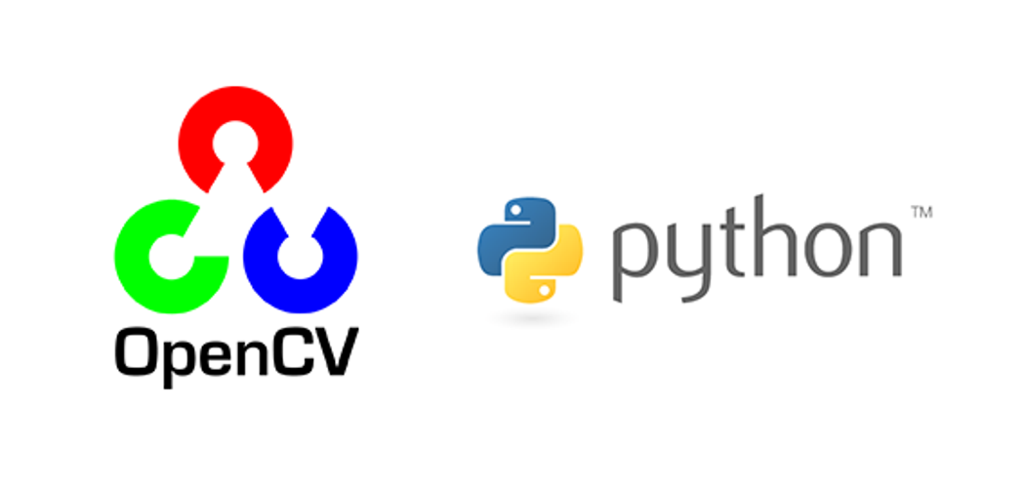

OpenCV (Open Source Computer Vision Library) is released under a BSD license and hence it’s free for both academic and commercial use. It has C++, Python and Java interfaces and supports Windows, Linux, Mac OS, iOS and Android. OpenCV was designed for computational efficiency and with a strong focus on real-time applications. Written in optimized C/C++, the library can take advantage of multi-core processing. Enabled with OpenCL, it can take advantage of the hardware acceleration of the underlying heterogeneous compute platform.
OpenCV (Open Source Computer Vision Library) is an open source computer vision and machine learning software library. OpenCV was built to provide a common infrastructure for computer vision applications and to accelerate the use of machine perception in the commercial products. Being a BSD-licensed product, OpenCV makes it easy for businesses to utilize and modify the code.
The library has more than 2500 optimized algorithms, which includes a comprehensive set of both classic and state-of-the-art computer vision and machine learning algorithms. These algorithms can be used to detect and recognize faces, identify objects, classify human actions in videos, track camera movements, track moving objects, extract 3D models of objects, produce 3D point clouds from stereo cameras, stitch images together to produce a high resolution image of an entire scene, find similar images from an image database, remove red eyes from images taken using flash, follow eye movements, recognize scenery and establish markers to overlay it with augmented reality, etc. OpenCV has more than 47 thousand people of user community and estimated number of downloads exceeding 14 million. The library is used extensively in companies, research groups and by governmental bodies.
Along with well-established companies like Google, Yahoo, Microsoft, Intel, IBM, Sony, Honda, Toyota that employ the library, there are many startups such as Applied Minds, VideoSurf, and Zeitera, that make extensive use of OpenCV. OpenCV’s deployed uses span the range from stitching streetview images together, detecting intrusions in surveillance video in Israel, monitoring mine equipment in China, helping robots navigate and pick up objects at Willow Garage, detection of swimming pool drowning accidents in Europe, running interactive art in Spain and New York, checking runways for debris in Turkey, inspecting labels on products in factories around the world on to rapid face detection in Japan.
It has C++, Python, Java and MATLAB interfaces and supports Windows, Linux, Android and Mac OS. OpenCV leans mostly towards real-time vision applications and takes advantage of MMX and SSE instructions when available. A full-featured CUDAand OpenCL interfaces are being actively developed right now. There are over 500 algorithms and about 10 times as many functions that compose or support those algorithms. OpenCV is written natively in C++ and has a templated interface that works seamlessly with STL containers.

OpenCV has a modular structure, which means that the package includes several shared or static libraries. The following modules are available:
- Core functionality (core) - a compact module defining basic data structures, including the dense multi-dimensional array Mat and basic functions used by all other modules.
- Image Processing (imgproc) - an image processing module that includes linear and non-linear image filtering, geometrical image transformations (resize, affine and perspective warping, generic table-based remapping), color space conversion, histograms, and so on.
- Video Analysis (video) - a video analysis module that includes motion estimation, background subtraction, and object tracking algorithms.
- Camera Calibration and 3D Reconstruction (calib3d) - basic multiple-view geometry algorithms, single and stereo camera calibration, object pose estimation, stereo correspondence algorithms, and elements of 3D reconstruction.
- 2D Features Framework (features2d) - salient feature detectors, descriptors, and descriptor matchers.
- Object Detection (objdetect) - detection of objects and instances of the predefined classes (for example, faces, eyes, mugs, people, cars, and so on).
- High-level GUI (highgui) - an easy-to-use interface to simple UI capabilities.
- Video I/O (videoio) - an easy-to-use interface to video capturing and video codecs.
- ... some other helper modules, such as FLANN and Google test wrappers, Python bindings, and others.

OpenCV was started at Intel in 1999 by Gary Bradsky and the first release came out in 2000. Vadim Pisarevsky joined Gary Bradsky to manage Intel’s Russian software OpenCV team. In 2005, OpenCV was used on Stanley, the vehicle who won 2005 DARPA Grand Challenge. Later its active development continued under the support of Willow Garage, with Gary Bradsky and Vadim Pisarevsky leading the project. Right now, OpenCV supports a lot of algorithms related to Computer Vision and Machine Learning and it is expanding day-by-day.
Currently OpenCV supports a wide variety of programming languages like C++, Python, Java etc and is available on different platforms including Windows, Linux, OS X, Android, iOS etc. Also, interfaces based on CUDA and OpenCL are also under active development for high-speed GPU operations.
OpenCV-Python is the Python API of OpenCV. It combines the best qualities of OpenCV C++ API and Python language.

OpenCV-Python
Python is a general purpose programming language started by Guido van Rossum, which became very popular in short time mainly because of its simplicity and code readability. It enables the programmer to express his ideas in fewer lines of code without reducing any readability.
Compared to other languages like C/C++, Python is slower. But another important feature of Python is that it can be easily extended with C/C++. This feature helps us to write computationally intensive codes in C/C++ and create a Python wrapper for it so that we can use these wrappers as Python modules. This gives us two advantages: first, our code is as fast as original C/C++ code (since it is the actual C++ code working in background) and second, it is very easy to code in Python. This is how OpenCV-Python works, it is a Python wrapper around original C++ implementation.
And the support of Numpy makes the task more easier. Numpy is a highly optimized library for numerical operations. It gives a MATLAB-style syntax. All the OpenCV array structures are converted to-and-from Numpy arrays. So whatever operations you can do in Numpy, you can combine it with OpenCV, which increases number of weapons in your arsenal. Besides that, several other libraries like SciPy, Matplotlib which supports Numpy can be used with this.
So OpenCV-Python is an appropriate tool for fast prototyping of computer vision problems

Automatic Memory Management
OpenCV handles all the memory automatically.
First of all, std::vector, cv::Mat, and other data structures used by the functions and methods have destructors that deallocate the underlying memory buffers when needed. This means that the destructors do not always deallocate the buffers as in case of Mat. They take into account possible data sharing. A destructor decrements the reference counter associated with the matrix data buffer. The buffer is deallocated if and only if the reference counter reaches zero, that is, when no other structures refer to the same buffer. Similarly, when a Mat instance is copied, no actual data is really copied. Instead, the reference counter is incremented to memorize that there is another owner of the same data. There is also the Mat::clone method that creates a full copy of the matrix data.

Automatic Allocation of the Output Data
OpenCV deallocates the memory automatically, as well as automatically allocates the memory for output function parameters most of the time. So, if a function has one or more input arrays (cv::Mat instances) and some output arrays, the output arrays are automatically allocated or reallocated. The size and type of the output arrays are determined from the size and type of input arrays. If needed, the functions take extra parameters that help to figure out the output array properties.
The array frame is automatically allocated by the >> operator since the video frame resolution and the bit-depth is known to the video capturing module. The array edges is automatically allocated by the cvtColor function. It has the same size and the bit-depth as the input array. The number of channels is 1 because the color conversion code cv::COLOR_BGR2GRAY is passed, which means a color to grayscale conversion. Note that frame and edges are allocated only once during the first execution of the loop body since all the next video frames have the same resolution. If you somehow change the video resolution, the arrays are automatically reallocated.
The key component of this technology is the Mat::create method. It takes the desired array size and type. If the array already has the specified size and type, the method does nothing. Otherwise, it releases the previously allocated data, if any (this part involves decrementing the reference counter and comparing it with zero), and then allocates a new buffer of the required size. Most functions call the Mat::create method for each output array, and so the automatic output data allocation is implemented.
Some notable exceptions from this scheme are cv::mixChannels, cv::RNG::fill, and a few other functions and methods. They are not able to allocate the output array, so you have to do this in advance.

Saturation Arithmetics
As a computer vision library, OpenCV deals a lot with image pixels that are often encoded in a compact, 8- or 16-bit per channel, form and thus have a limited value range. Furthermore, certain operations on images, like color space conversions, brightness/contrast adjustments, sharpening, complex interpolation (bi-cubic, Lanczos) can produce values out of the available range. If you just store the lowest 8 (16) bits of the result, this results in visual artifacts and may affect a further image analysis. To solve this problem, the so-called saturation arithmetics is used. For example, to store r, the result of an operation, to an 8-bit image, you find the nearest value within the 0..255 range:
I(x,y)=min(max(round(r),0),255)
Similar rules are applied to 8-bit signed, 16-bit signed and unsigned types. This semantics is used everywhere in the library. In C++ code, it is done using the cv::saturate_cast<> functions that resemble standard C++ cast operations.

Fixed Pixel Types. Limited Use of Templates
Templates is a great feature of C++ that enables implementation of very powerful, efficient and yet safe data structures and algorithms. However, the extensive use of templates may dramatically increase compilation time and code size. Besides, it is difficult to separate an interface and implementation when templates are used exclusively. This could be fine for basic algorithms but not good for computer vision libraries where a single algorithm may span thousands lines of code. Because of this and also to simplify development of bindings for other languages, like Python, Java, Matlab that do not have templates at all or have limited template capabilities, the current OpenCV implementation is based on polymorphism and runtime dispatching over templates. In those places where runtime dispatching would be too slow (like pixel access operators), impossible (generic cv::Ptr<> implementation), or just very inconvenient (cv::saturate_cast<>()) the current implementation introduces small template classes, methods, and functions. Anywhere else in the current OpenCV version the use of templates is limited.
Consequently, there is a limited fixed set of primitive data types the library can operate on. That is, array elements should have one of the following types:
- 8-bit unsigned integer (uchar)
- 8-bit signed integer (schar)
- 16-bit unsigned integer (ushort)
- 16-bit signed integer (short)
- 32-bit signed integer (int)
- 32-bit floating-point number (float)
- 64-bit floating-point number (double)
- a tuple of several elements where all elements have the same type (one of the above). An array whose elements are such tuples, are called multi-channel arrays, as opposite to the single-channel arrays, whose elements are scalar values. The maximum possible number of channels is defined by the CV_CN_MAX constant, which is currently set to 512.
For these basic types, the following enumeration is applied:
enum { CV_8U=0, CV_8S=1, CV_16U=2, CV_16S=3, CV_32S=4, CV_32F=5, CV_64F=6 };
Multi-channel (n-channel) types can be specified using the following options:
- CV_8UC1 ... CV_64FC4 constants (for a number of channels from 1 to 4)
- CV_8UC(n) ... CV_64FC(n) or CV_MAKETYPE(CV_8U, n) ... CV_MAKETYPE(CV_64F, n) macros when the number of channels is more than 4 or unknown at the compilation time.
Examples:
Mat mtx(3, 3, CV_32F); // make a 3x3 floating-point matrix
Mat cmtx(10, 1, CV_64FC2); // make a 10x1 2-channel floating-point
// matrix (10-element complex vector)
Mat img(Size(1920, 1080), CV_8UC3); // make a 3-channel (color) image
// of 1920 columns and 1080 rows.
Mat grayscale(image.size(), CV_MAKETYPE(image.depth(), 1)); // make a 1-channel image of
// the same size and same
// channel type as img
Arrays with more complex elements cannot be constructed or processed using OpenCV. Furthermore, each function or method can handle only a subset of all possible array types. Usually, the more complex the algorithm is, the smaller the supported subset of formats is. See below typical examples of such limitations:
- The face detection algorithm only works with 8-bit grayscale or color images.
- Linear algebra functions and most of the machine learning algorithms work with floating-point arrays only.
- Basic functions, such as cv::add, support all types.
- Color space conversion functions support 8-bit unsigned, 16-bit unsigned, and 32-bit floating-point types.
The subset of supported types for each function has been defined from practical needs and could be extended in future based on user requests.

InputArray and OutputArray
Many OpenCV functions process dense 2-dimensional or multi-dimensional numerical arrays. Usually, such functions take cppMat as parameters, but in some cases it's more convenient to use std::vector<> (for a point set, for example) or cv::Matx<> (for 3x3 homography matrix and such). To avoid many duplicates in the API, special "proxy" classes have been introduced. The base "proxy" class is cv::InputArray. It is used for passing read-only arrays on a function input. The derived from InputArray class cv::OutputArray is used to specify an output array for a function. Normally, you should not care of those intermediate types (and you should not declare variables of those types explicitly) - it will all just work automatically. You can assume that instead of InputArray/OutputArray you can always use Mat, std::vector<>, cv::Matx<>, cv::Vec<> or cv::Scalar. When a function has an optional input or output array, and you do not have or do not want one, pass cv::noArray().

Error Handling
OpenCV uses exceptions to signal critical errors. When the input data has a correct format and belongs to the specified value range, but the algorithm cannot succeed for some reason (for example, the optimization algorithm did not converge), it returns a special error code (typically, just a boolean variable).
The exceptions can be instances of the cv::Exception class or its derivatives. In its turn, cv::Exception is a derivative of std::exception. So it can be gracefully handled in the code using other standard C++ library components.

Multi-threading and Re-enterability
The current OpenCV implementation is fully re-enterable. That is, the same function or the same methods of different class instances can be called from different threads. Also, the same Mat can be used in different threads because the reference-counting operations use the architecture-specific atomic instructions.


Getting started with OpenCV's Python bindings is actually much easier than many people make it out to be initially. You will need two main libraries, with an optional third: python-OpenCV, Numpy, and Matplotlib.

Windows Users:
python-OpenCV - There are alternative methods, but this is the easiest. Download the appropriate wheel (.whl) file, and install using pip. See video for help.
pip install numpy
pip install matplotlib
Not familiar with using pip? See the Pip installation tutorial for help.

Linux / Mac Users:
pip3 install numpy or apt-get install python3-numpy. You may need to apt-get install python3-pip.
pip3 install matplotlib or apt-get install python3-matplotlib.
apt-get install python3-OpenCV

Matplotlib is an optional choice for displaying frames from video or images. We will show a couple of examples using it here. Numpy is used for all things "numbers and Python." We are mainly making use of Numpy's array functionality. Finally, we are using the python-specific bindings for OpenCV called python-OpenCV.
There are some operations for OpenCV that you will not be able to do without a full installation of OpenCV (about 3GB in size), but you can actually do quite a bit with the fairly minimal installation of python-OpenCV. We will wind up using the full installation of OpenCV later in this series, so you can feel free to get it if you like, but these 3 modules will keep us busy for a while!
Make sure your installations were successful by running Python, and doing:
import cv2
import matplotlib
import numpy
If you get no errors, then you are ready to go. Ready? Let's dive off the deep-end!
First, we should understand a few basic assumptions and paradigms when it comes to image and video analysis. With the way just about every video camera records today, recordings are actually frames, displayed one after another, 30-60+ times a second. At the core, however, they are static frames, just like images. Thus, image recognition and video analysis use identical methods for the most part. Some things, like directional tracking, is going to require a succession of images (frames), but something like facial detection, or object recognition can be done with almost the exact same code on images and video.
Next, a lot of image and video analysis boils down to simplifying the source as much as possible. This almost always begins with a conversion to grayscale, but it can also be a color filter, gradient, or a combination of these. From here, we can do all sorts of analysis and transformations to the source. Generally, what winds up happening is there is a transformation done, then analysis, then any overlays that we wish to apply are applied back to the original source, which is why you can often see the "finished product" of maybe object or facial recognition being shown on a full-color image or video. Rarely is the data actually processed in raw form like this, however. Some examples of what we can do at a basic level. All of these are done with a basic web cam, nothing special:

Background Subtracting:
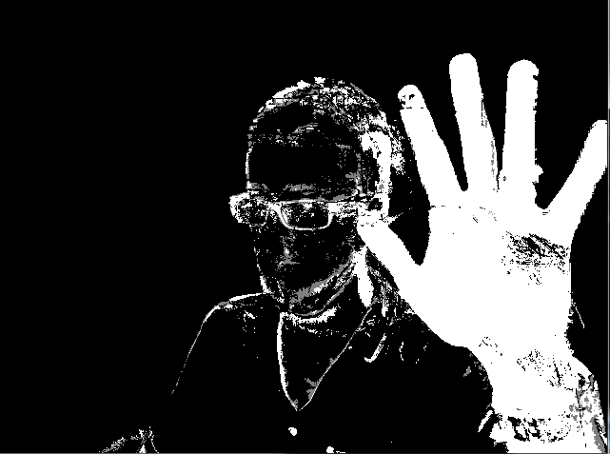

Color filtering:
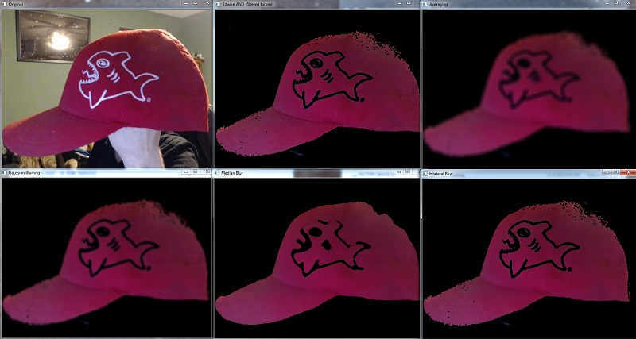

Edge detection:
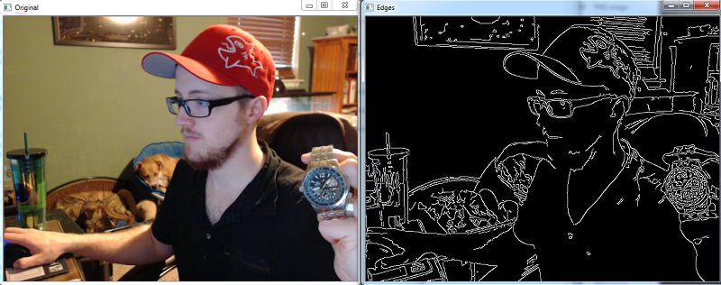

Numpy


NumPy is a library for the Python programming language, adding support for large, multi-dimensional arrays and matrices, along with a large collection of high-level mathematical functions to operate on these arrays. The ancestor of NumPy, Numeric, was originally created by Jim Hugunin with contributions from several other developers. In 2005, Travis Oliphant created NumPy by incorporating features of the competing Numarray into Numeric, with extensive modifications. NumPy is open-source software and has many contributors.
The Python programming language was not initially designed for numerical computing, but attracted the attention of the scientific and engineering community early on, so that a special interest group called matrix-sig was founded in 1995 with the aim of defining an array computing package. Among its members was Python designer and maintainer Guido van Rossum, who implemented extensions to Python's syntax (in particular the indexing syntax) to make array computing easier.
An implementation of a matrix package was completed by Jim Fulton, then generalized by Jim Hugunin to become Numeric,[4] also variously called Numerical Python extensions or NumPy. Hugunin, a graduate student at Massachusetts Institute of Technology (MIT), joined the Corporation for National Research Initiatives (CNRI) to work on JPython in 1997 leaving Paul Dubois of Lawrence Livermore National Laboratory (LLNL) to take over as maintainer. Other early contributors include David Ascher, Konrad Hinsen and Travis Oliphant.
A new package called Numarray was written as a more flexible replacement for Numeric. Like Numeric, it is now deprecated. Numarray had faster operations for large arrays, but was slower than Numeric on small ones, so for a time both packages were used for different use cases. The last version of Numeric v24.2 was released on 11 November 2005 and numarray v1.5.2 was released on 24 August 2006.
There was a desire to get Numeric into the Python standard library, but Guido van Rossum decided that the code was not maintainable in its state then.
In early 2005, NumPy developer Travis Oliphant wanted to unify the community around a single array package and ported Numarray's features to Numeric, releasing the result as NumPy 1.0 in 2006.[7] This new project was part of SciPy. To avoid installing the large SciPy package just to get an array object, this new package was separated and called NumPy. Support for Python 3 was added in 2011 with NumPy version 1.5.0.[13]
In 2011, PyPy started development on an implementation of the NumPy API for PyPy. It is not yet fully compatible with NumPy.
NumPy targets the CPython reference implementation of Python, which is a non-optimizing bytecode interpreter. Mathematical algorithms written for this version of Python often run much slower than compiled equivalents. NumPy addresses the slowness problem partly by providing multidimensional arrays and functions and operators that operate efficiently on arrays, requiring rewriting some code, mostly inner loops using NumPy.

Using NumPy in Python gives functionality comparable to MATLAB since they are both interpreted,[16] and they both allow the user to write fast programs as long as most operations work on arrays or matrices instead of scalars. In comparison, MATLAB boasts a large number of additional toolboxes, notably Simulink, whereas NumPy is intrinsically integrated with Python, a more modern and complete programming language. Moreover, complementary Python packages are available; SciPy is a library that adds more MATLAB-like functionality and Matplotlib is a plotting package that provides MATLAB-like plotting functionality. Internally, both MATLAB and NumPy rely on BLAS and LAPACK for efficient linear algebra computations.
Python bindings of the widely used computer vision library OpenCV utilize NumPy arrays to store and operate on data. Since images with multiple channels are simply represented as three-dimensional arrays, indexing, slicing or masking with other arrays are very efficient ways to access specific pixels of an image. The NumPy array as universal data structure in OpenCV for images, extracted feature points, filter kernels and many more vastly simplifies the programming workflow and debugging.

Traits
NumPy targets the CPython reference implementation of Python, which is a non-optimizing bytecode interpreter. Mathematical algorithms written for this version of Python often run much slower than compiled equivalents. NumPy addresses the slowness problem partly by providing multidimensional arrays and functions and operators that operate efficiently on arrays, requiring rewriting some code, mostly inner loops using NumPy.
Using NumPy in Python gives functionality comparable to MATLAB since they are both interpreted,^{[16]} and they both allow the user to write fast programs as long as most operations work on arrays or matrices instead of scalars. In comparison, MATLAB boasts a large number of additional toolboxes, notably Simulink, whereas NumPy is intrinsically integrated with Python, a more modern and complete programming language. Moreover, complementary Python packages are available; SciPy is a library that adds more MATLAB-like functionality and Matplotlib is a plotting package that provides MATLAB-like plotting functionality. Internally, both MATLAB and NumPy rely on BLAS and LAPACK for efficient linear algebra computations.
Python bindings of the widely used computer vision library OpenCV utilize NumPy arrays to store and operate on data. Since images with multiple channels are simply represented as three-dimensional arrays, indexing, slicing or masking with other arrays are very efficient ways to access specific pixels of an image. The NumPy array as universal data structure in OpenCV for images, extracted feature points, filter kernels and many more vastly simplifies the programming workflow and debugging.

The ndarray data structure
The core functionality of NumPy is its "ndarray", for n-dimensional array, data structure. These arrays are strided views on memory.^{[7]} In contrast to Python's built-in list data structure (which, despite the name, is a dynamic array), these arrays are homogeneously typed: all elements of a single array must be of the same type.
Such arrays can also be views into memory buffers allocated by C/C++, Cython, and Fortran extensions to the CPython interpreter without the need to copy data around, giving a degree of compatibility with existing numerical libraries. This functionality is exploited by the SciPy package, which wraps a number of such libraries (notably BLAS and LAPACK). NumPy has built-in support for memory-mapped ndarrays.^{[7]}

Limitations
Inserting or appending entries to an array is not as trivially possible as it is with Python's lists. The np.pad(...) routine to extend arrays actually creates new arrays of the desired shape and padding values, copies the given array into the new one and returns it. NumPy's np.concatenate([a1,a2]) operation does not actually link the two arrays but returns a new one, filled with the entries from both given arrays in sequence. Reshaping the dimensionality of an array with np.reshape(...) is only possible as long as the number of elements in the array does not change. These circumstances originate from the fact that NumPy's arrays must be views on contiguous memory buffers. A replacement package called Blaze attempts to overcome this limitation.^{[17]}
Algorithms that are not expressible as a vectorized operation will typically run slowly because they must be implemented in "pure Python", while vectorization may increase memory complexity of some operations from constant to linear, because temporary arrays must be created that are as large as the inputs. Runtime compilation of numerical code has been implemented by several groups to avoid these problems; open source solutions that interoperate with NumPy
include scipy.weave, numexpr^{[18]} and Numba.^{[19]} Cython and Pythran are static-compiling alternatives to these.

The Basics
NumPy’s main object is the homogeneous multidimensional array. It is a table of elements (usually numbers), all of the same type, indexed by a tuple of positive integers. In NumPy dimensions are called axes.
For example, the coordinates of a point in 3D space [1, 2, 1] has one axis. That axis has 3 elements in it, so we say it has a length of 3. In the example pictured below, the array has 2 axes. The first axis has a length of 2, the second axis has a length of 3.
[[ 1., 0., 0.],
[ 0., 1., 2.]]
NumPy’s array class is called ndarray. It is also known by the alias array. Note that numpy.array is not the same as the Standard Python Library class array.array, which only handles one-dimensional arrays and offers less functionality. The more important attributes of an ndarray object are:
ndarray.ndim
the number of axes (dimensions) of the array.
ndarray.shape
the dimensions of the array. This is a tuple of integers indicating the size of the array in each dimension. For a matrix with nrows and m columns, shape will be (n,m). The length of the shape tuple is therefore the number of axes, ndim.
ndarray.size
the total number of elements of the array. This is equal to the product of the elements of shape.
ndarray.dtype
an object describing the type of the elements in the array. One can create or specify dtype’s using standard Python types. Additionally NumPy provides types of its own. numpy.int32, numpy.int16, and numpy.float64 are some examples.
ndarray.itemsize
the size in bytes of each element of the array. For example, an array of elements of type float64 has itemsize 8 (=64/8), while one of type complex32 has itemsize 4 (=32/8). It is equivalent to ndarray.dtype.itemsize.
ndarray.data
the buffer containing the actual elements of the array. Normally, we won’t need to use this attribute because we will access the elements in an array using indexing facilities.

An example
>>>
>>> import numpy as np
>>> a = np.arange(15).reshape(3, 5)
>>> a
array([[ 0, 1, 2, 3, 4],
[ 5, 6, 7, 8, 9],
[10, 11, 12, 13, 14]])
>>> a.shape
(3, 5)
>>> a.ndim
2
>>> a.dtype.name
'int64'
>>> a.itemsize
8
>>> a.size
15
>>> type(a)
<type 'numpy.ndarray'>
>>> b = np.array([6, 7, 8])
>>> b
array([6, 7, 8])
>>> type(b)
<type 'numpy.ndarray'>

Array Creation
There are several ways to create arrays.
For example, you can create an array from a regular Python list or tuple using the array function. The type of the resulting array is deduced from the type of the elements in the sequences.
>>>
>>> import numpy as np
>>> a = np.array([2,3,4])
>>> a
array([2, 3, 4])
>>> a.dtype
dtype('int64')
>>> b = np.array([1.2, 3.5, 5.1])
>>> b.dtype
dtype('float64')
A frequent error consists in calling array with multiple numeric arguments, rather than providing a single list of numbers as an argument.
>>>
>>> a = np.array(1,2,3,4) # WRONG
>>> a = np.array([1,2,3,4]) # RIGHT
array transforms sequences of sequences into two-dimensional arrays, sequences of sequences of sequences into three-dimensional arrays, and so on.
>>>
>>> b = np.array([(1.5,2,3), (4,5,6)])
>>> b
array([[ 1.5, 2. , 3. ],
[ 4. , 5. , 6. ]])
The type of the array can also be explicitly specified at creation time:
>>>
>>> c = np.array( [ [1,2], [3,4] ], dtype=complex )
>>> c
array([[ 1.+0.j, 2.+0.j],
[ 3.+0.j, 4.+0.j]])
Often, the elements of an array are originally unknown, but its size is known. Hence, NumPy offers several functions to create arrays with initial placeholder content. These minimize the necessity of growing arrays, an expensive operation.
The function zeros creates an array full of zeros, the function ones creates an array full of ones, and the function empty creates an array whose initial content is random and depends on the state of the memory. By default, the dtype of the created array isfloat64.
>>>
>>> np.zeros( (3,4) )
array([[ 0., 0., 0., 0.],
[ 0., 0., 0., 0.],
[ 0., 0., 0., 0.]])
>>> np.ones( (2,3,4), dtype=np.int16 ) # dtype can also be specified
array([[[ 1, 1, 1, 1],
[ 1, 1, 1, 1],
[ 1, 1, 1, 1]],
[[ 1, 1, 1, 1],
[ 1, 1, 1, 1],
[ 1, 1, 1, 1]]], dtype=int16)
>>> np.empty( (2,3) ) # uninitialized, output may vary
array([[ 3.73603959e-262, 6.02658058e-154, 6.55490914e-260],
[ 5.30498948e-313, 3.14673309e-307, 1.00000000e+000]])
To create sequences of numbers, NumPy provides a function analogous to range that returns arrays instead of lists.
>>>
>>> np.arange( 10, 30, 5 )
array([10, 15, 20, 25])
>>> np.arange( 0, 2, 0.3 ) # it accepts float arguments
array([ 0. , 0.3, 0.6, 0.9, 1.2, 1.5, 1.8])
When arange is used with floating point arguments, it is generally not possible to predict the number of elements obtained, due to the finite floating point precision. For this reason, it is usually better to use the function linspace that receives as an argument the number of elements that we want, instead of the step:
>>>
>>> from numpy import pi
>>> np.linspace( 0, 2, 9 ) # 9 numbers from 0 to 2
array([ 0. , 0.25, 0.5 , 0.75, 1. , 1.25, 1.5 , 1.75, 2. ])
>>> x = np.linspace( 0, 2*pi, 100 ) # useful to evaluate function at lots of points
>>> f = np.sin(x)

OUTPUT IMAGES:
Here you can add your sample output images.
Conclusion:

In conclusion, the advanced driver's drowsiness detection system utilizing OpenCV to monitor eye and mouth status represents a significant stride forward in ensuring road safety. By harnessing the power of computer vision, this technology addresses a critical concern in the transportation industry – driver fatigue.

The integration of OpenCV's capabilities for facial feature detection and tracking enables real-time monitoring of the driver's eyes and mouth, providing an accurate indication of their drowsiness level.
Through this technology, the system can promptly identify instances of closed eyes or yawns, two telltale signs of drowsiness, and issue timely alerts to the driver. The precision and immediacy of these alerts contribute to preventing potential accidents caused by driver fatigue, safeguarding both the driver and fellow road users.

Moreover, the reliance on OpenCV offers flexibility and scalability to this solution. It can be seamlessly integrated into existing driver assistance systems or adopted as a standalone safety feature across a wide range of vehicles. By utilizing an open-source library, developers can tailor the system to accommodate diverse driving conditions, making it adaptable to varying levels of lighting, vehicle types, and driver behaviors.

As we move towards a future focused on enhancing road safety and minimizing accidents, this advanced drowsiness detection system stands as a testament to the potential of technology in mitigating human error. By accurately detecting and responding to driver drowsiness, it reinforces the notion that innovation in the realm of computer vision can play a pivotal role in revolutionizing road safety and ensuring safer journeys for everyone

